From the Flybridge 6 May 2017

Well... not unsurprisingly, the deal with The Coffs Coast Advocate didn’t even last one summer. So that’s the end of the Advocate column folks, but as promised, this website edition will keep going. Hopefully, it will continue as a weekly feature here, so if you have any news or photos, send ‘em in, and I’ll publish it along with my usual jottings so that the 200 or so regular daily visitors can keep up to date with the Coffs Coast game fishing scene.

The upside of the move away from the Advocate is that the column will be able to go back to a sharper focus on game fishing matters, and won’t need to be as generic or broadly focused to keep the interest of the wide range of readers of the paper.

So... what do you write about when the usual flow of weekly game fishing reports on the Coffs Coast dries up and the morning blogs are full of eye-popping accounts of boats on the Gold Coast raising a handful of fish on every outing...?

It's a question that's been exercising me on and off for weeks as our disastrous game fishing season draws to a close with absolutely no encouraging signs of the late season bite that most game boat skippers were desperately hoping would materialise. Without anything to fire up anglers and crews at this time of year, and with the most miserable season in memory still looming large, boats are staying tied up in the marina growing weed or sitting unused on trailers in backyards, so there's going to have to be some sort of exceptional late surge of fish to give anglers a chance to post a season result that puts the cost of this sport into an acceptable context.

After this season, I think I can safely say that on a dollars per fish tagged basis, we probably have (temporarily at least...) the most expensive marlin fishing destination on the planet.

So... That leaves us looking towards next season rather than looking over our shoulders at the season that’s FUBAR. Admittedly, there’s still a month left, but the odds are long...

Changing the subject slightly, has anyone who uses the Navionics data cards in their onboard navigation systems noticed that we really do seem to have better structure out beyond the shelf than most of us were aware? I’m sure it’s not confined to the Navionics data cards alone, as most of the suppliers get pretty good data from the central national databases, which is a common starting point.

However, Navionics has an additional dynamic database system that allows boats and ships equipped with the latest generation of plotters to record the bottom profile they pass over and store it all in memory on their removable card. Then, once per week, or after every trip if you like, when you take the card home and place it in a reader that links to the Navionics mainframe, all your bottom sonar data from your last trip(s) is uploaded to the Navionics central mainframe.

This user data is then massaged by the system and is used to update the existing map database which then is downloaded as an updated chart to your memory card whenever you sign in to Navionics. There’s little doubt that at least 50% of the new bottom mapping data around our coasts comes from commercial or scientific survey ships like the CSIRO’s Investigator which no doubt hoovers up a huge amount of detail whenever it passes anywhere in transit. However, there are obviously local boats and transiting private vessels that actively participate in this program, uploading recorded bottom structural data whenever they’ve been to sea.

Sadly, my boat isn't one of them, because my plotter is a generation behind; however, I do have one of the latest Navioics chips, so whenever I link it to their server, I get all the latest data and thus benefit from the information uploaded by boats that have recorded bottom profiles off the Coffs Coast as recently as 24 hours prior.

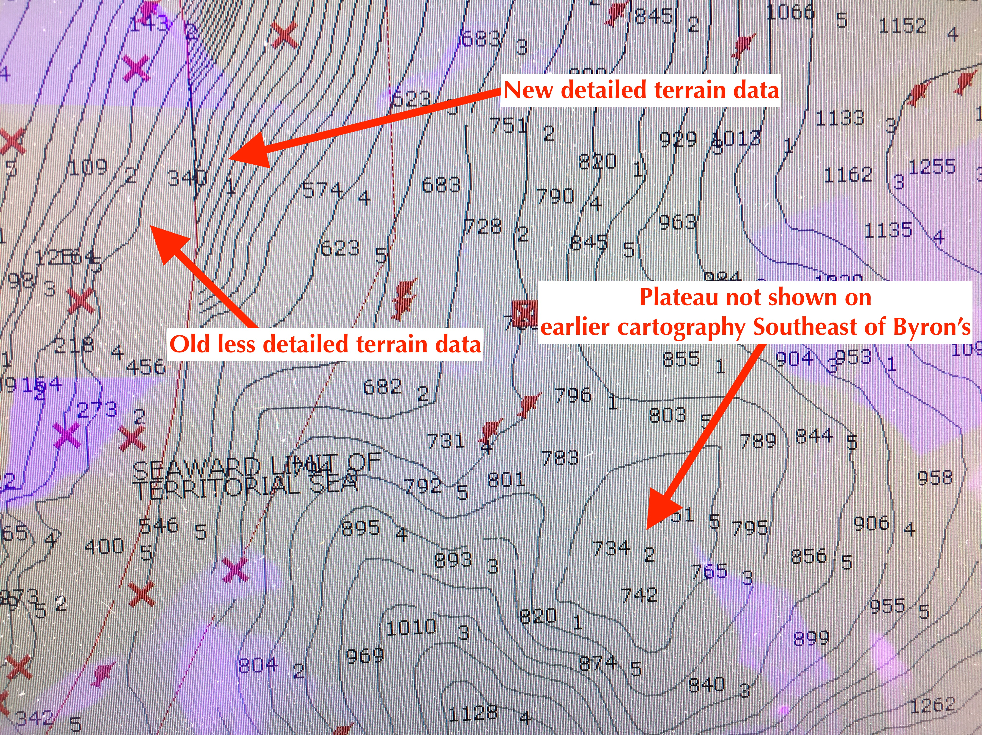

The screen shot above taken from my GPS map screen on my plotter shows an area filled in by much more detailed recent bottom mapping data in the structure around Byron’s Mark. There’s a clearly defined plateau southeast of Byron’s that never showed on my old maps, and south of that, a much deeper and steeper Sawtell Canyon profile is revealed. Down the left side of the screen shot, you can see the red arc where only old data with less contour detail still remains.

In fact, I'm seeing some fairly impressive structure appearing on my plotter chart after almost every new database update, and am finding that our local canyons are much more sharply defined and structurally more complex than both the (unclassified) paper Naval charts or older data cards had us believing. Huge canyons, a couple of great plateaus, and a really complex drowned valley system feeding up to the old waterfall that we call The Hole are all filling in on my chart where before there was either flat ground or relatively shallow canyons shown just a few years ago.

Sadly, despite the great new detail, we clearly don't have the sort of features we can get really excited about like seamounts or 1000m pinnacles, but what is now being slowly revealed by this constantly revised data out there is pretty encouraging, and has certainly changed my fishing tracks and moved some of my favourite locations. It's only been since the latest generation of recreational sounders with their higher power, better software, and dramatically increased memory capacity that we've been able to benefit from all these individual user community uploads, but the wealth of data now flowing in is increasing exponentially as more boats upgrade to the latest gear.

And as I mentioned, even if your gear isn't the latest, once you buy a new data chip you still get to download all this data yourself.

Once you get one of the new data chips (admittedly not cheap at $300+), you'll see what I mean... Suddenly all that flat ground and previously featureless undersea terrain out there off the edge of the shelf isn't so featureless any more.

The week ahead looks unremarkable as usual. Today has easing southerly breezes that should give way to the typical wind profile for late summer tomorrow, with a light offshore breeze at dawn swinging to a light nor'easter in the afternoon. Normally, that would have most of us stirred up enough to go out chasing a late marlin or an early yellowfin, but with the East Australian Current still completely missing in action, the hot blue marlin bite that keeps making the front page of the Black Marlin Blog is unlikely to come further south than the border. Meanwhile, the YFT and striped marlin aren't going to bother with this place while the baitfish desert off Coffs is our only newsworthy feature...

With only a couple more competition days to the season, it would do everyone good to go out for a fish on both of them, particularly if the EAC kicks back into action and the chances of a late bite pick up.

Rick O’Ferrall
www.FromtheFlybridge.com

