From the Flybridge 18 March 2017

Thanks to the extremely poor weather and a marlin free ocean stained with floodwater, there’s once again a glaring lack of game fishing news. Consequently, one of the biggest problems crews may face once the upcoming Heavy Tackle Challenge game fishing tournament kicks off next weekend will be a lack of practice.

Other anglers may scoff at this observation, believing that fishing is like riding a bike. Maybe so if we’re talking about snagging snapper off the bottom, but when it comes to hooking up and successfully fighting a muscular adult blue marlin with lots of attitude, split second reactions that only come from doing it every week can mean the difference between a lost versus a tagged fish. And in the upcoming tournament environment, a split second can make a $5000 prize money difference.
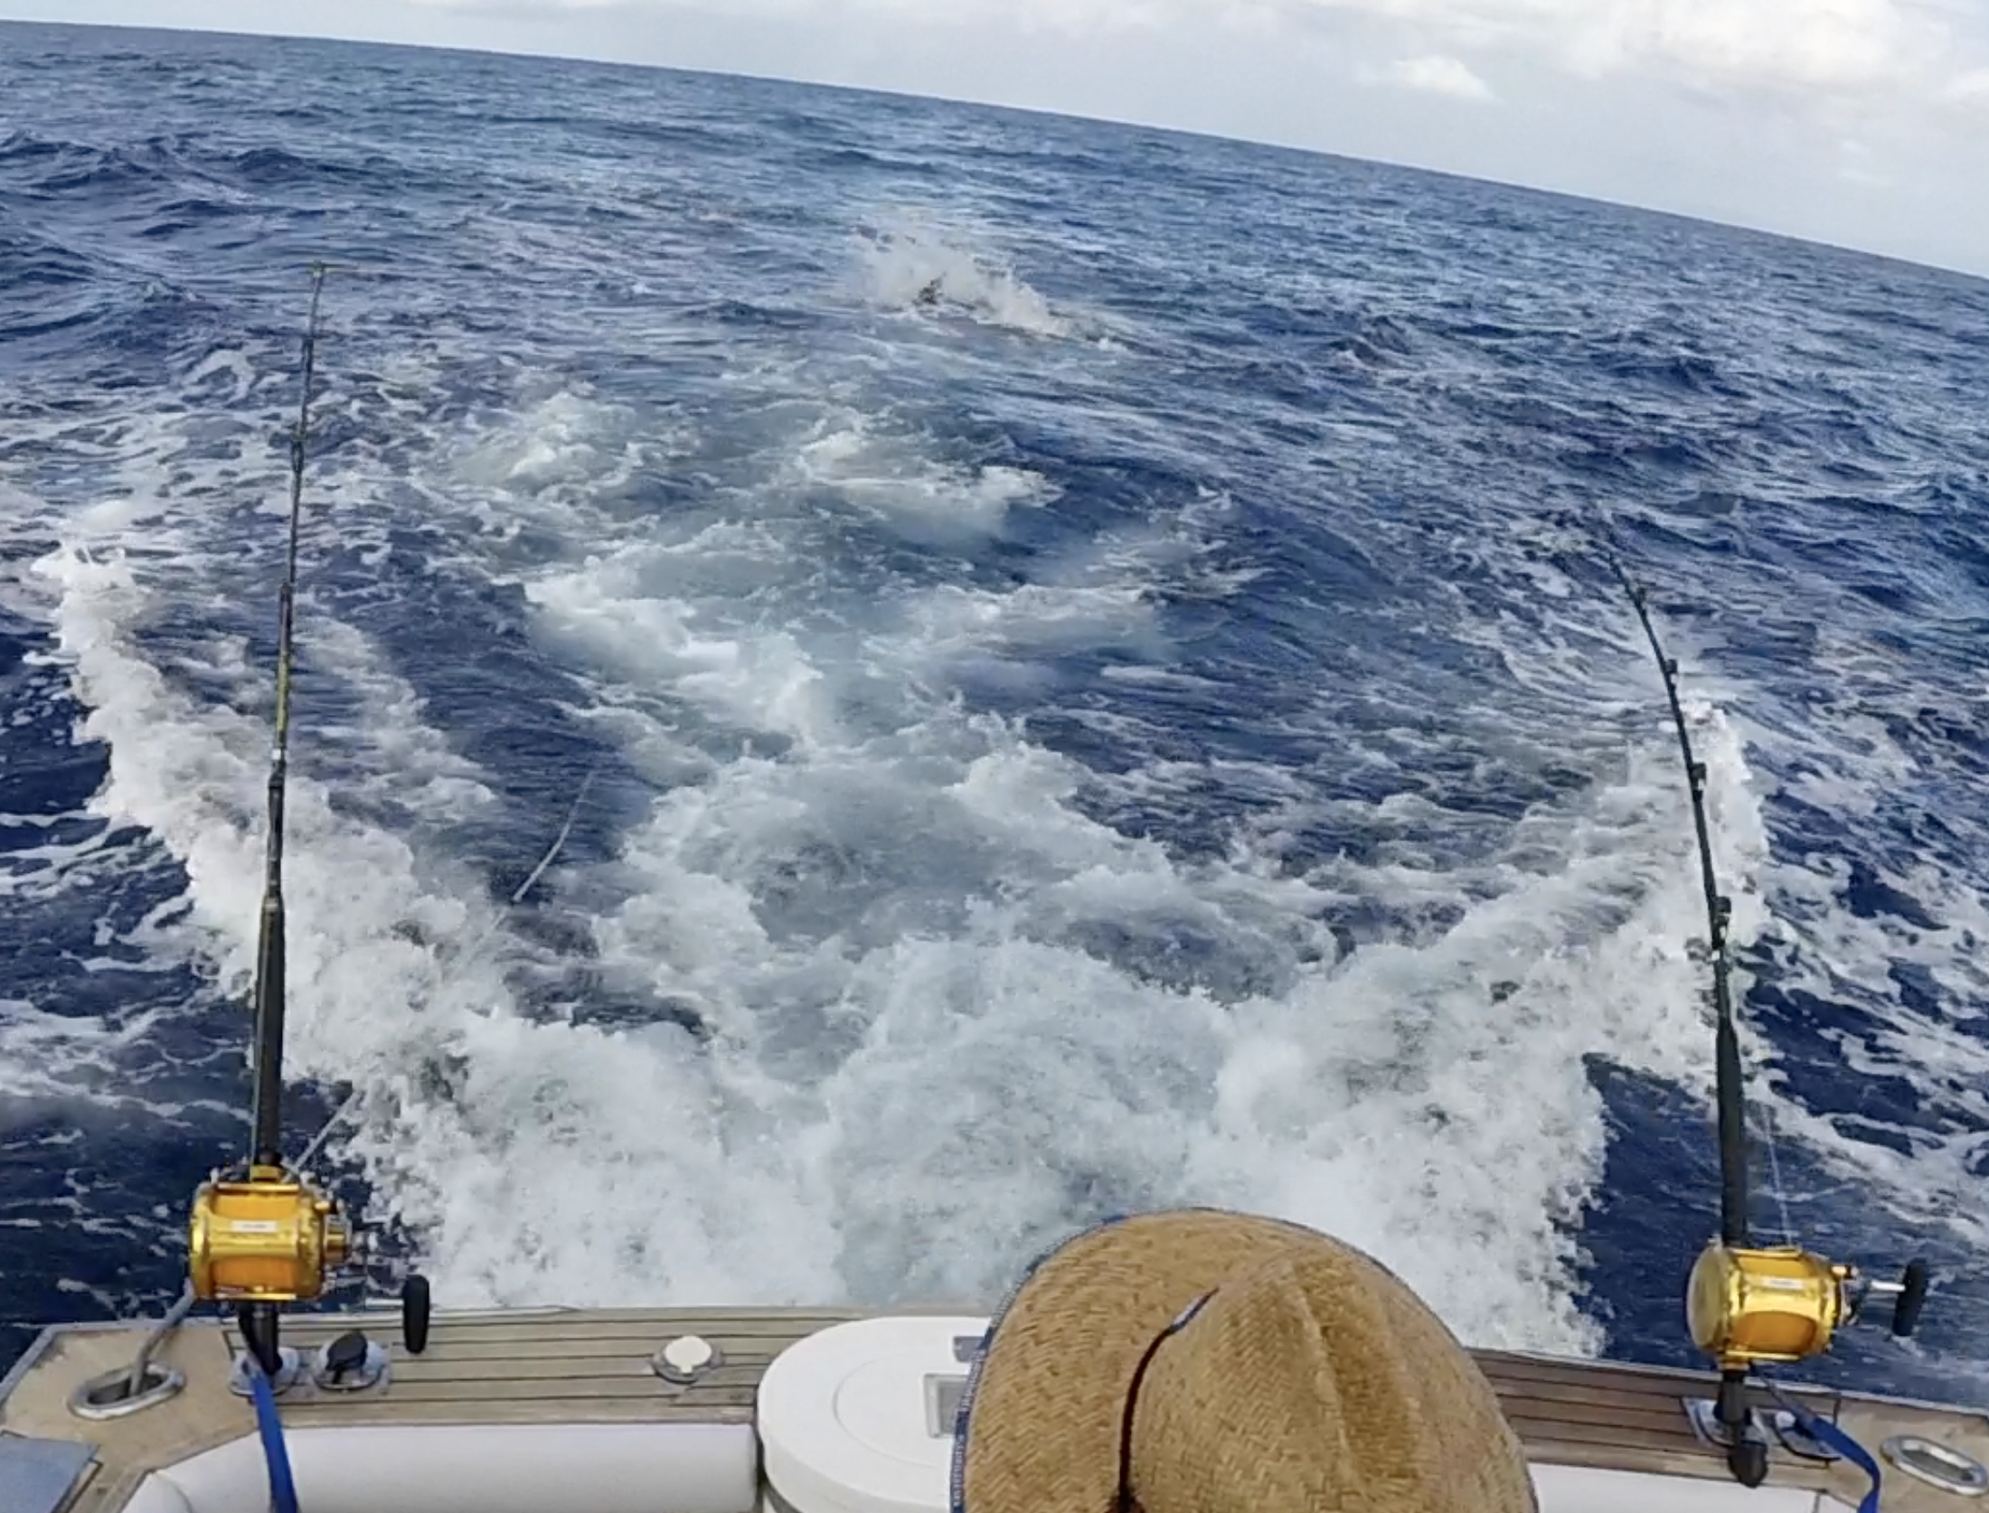
It’s game on as a big blue marlin smashes a lure and starts the festivities

This week’s photo shows the exact moment when a 200+kg blue marlin crash-tackled a lure only a few metres behind a game boat in last year’s Heavy Tackle tournament. The fish has just hooked up on the rod bent over hard on the right, and as it turns away to run, the crew member under the straw hat is taking a second or so to process this before instinctive reactions take over. What happens next makes all the difference.

Imagine an uneventful blue water day after hours of looking at the empty wake and only the humming of the diesel and some occasional crew conversation in the background. Then, kaboom - a massive hookup! Within two seconds of this happening, the skipper will have pushed the power up to get the boat surging away from the fish, the marlin will have accelerated to about 30 kilometres an hour in the other direction, and each crew member will have bounded across to their assigned rod to clear the deck, and, in the designated angler’s case, grab the live rod and strap onto the fish.

There’s very little time to think before the crew have to get deck cleared and the gear stowed to allow the skipper to manoeuvre the boat away from the fish, ensuring that the marlin has absolutely no chance of getting enough slack line to shake its head, throw the hook, and disappear before the angler takes over.

And then, less than 30 seconds after the scene in the photo, everything goes quiet, with nothing but the sound of the angler grunting with the strain as the fish settles into the fight and they size each other up.

Rick O’Ferrall
www.FromtheFlybridge.com

