From the Flybridge - 1 April 2017 Rick O’Ferrall
www.FrontheFlybridge.com

Last weekend’s Heavy Tackle Challenge game fishing tournament conducted from Coffs Harbour saw 20 local and visiting boats and crews competing for a prize pool that included $8000 for first place in the two day competition.

Conditions for competitors were difficult, with choppy seas, and floodwaters from the northern rivers staining the ocean a nasty green well out beyond the edge of the continental shelf. Add to this the fact that the big blue marlin that normally turn up to make this tournament one of the best on the calendar have continued to avoid the Coffs Coast in record numbers this summer, making for very tough angling.

By the end of competitive fishing on Sunday, local game boat Seaborn, skippered by Clayton Livingston, and with a gun crew of Billy Livingston, Dylan Steel and Andrew Barter had secured
enough points to sweep into the lead and win the tournament. Seaborn’s first scoring marlin was a juvenile black that smoked a lure and hooked up solid, putting Clayton and his crew into the lead early on Day One.
Billy Livingston preparing to release the tournament winning striped marlin. Photo - Andrew Barter.
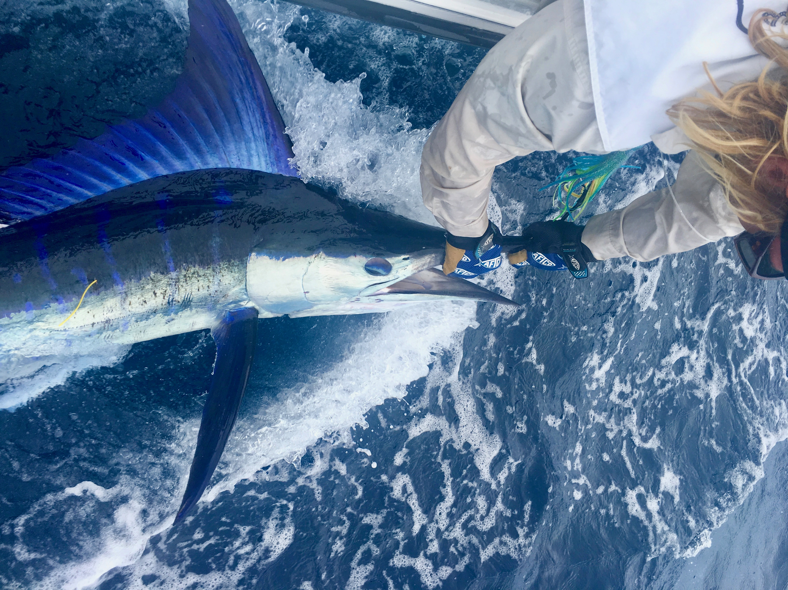

The fish that secured the winner’s trophy and a big cheque for the Seaborn team was one of the prettiest striped marlin you’ll ever see, as the accompanying photo shows. The marlin hit a flying fish lure and was none too happy about the whole business, and its display of displeasure resulted in this superb photo of the fish all lit up in the beautiful blue neon colours that leave no doubt about its mood.

Second place in the tournament went to No Frills, skippered by Charles La Coste, third was Rob Glover’s boat Kanaloa, while fourth place getter was Hemingway, skippered by Marcus Blackwell.

Despite the less than stellar marlin fishing this whole summer and over last weekend in particular, this tournament has turned into one of the biggest marlin fishing competitions up on the north coast of NSW in the eight years since it started, thanks to enthusiastic sponsors and the attraction of the Solitary Islands offshore game fishing grounds.

Once we get past the last of this summer’s disruptive floods, cyclones and nasty offshore wind patterns, we can only hope that the final two months of the local game fishing season will settle down and we’ll see the marlin return and produce the sort of fishing we’re used to here.

