From the Flybridge 25 February 2017

While it may seem a bit like an apples and oranges comparison, big game fishermen 30 km out on the edge of the continental shelf chasing a 300kg blue marlin and a trout fisherman standing on the edge of a small stream chasing a 1kg wild trout up on the Dorrigo Plateau surprisingly have several things in common.

Most importantly, they both try as best they can to follow the old fly fishing adage “…match the hatch”. This means that if you can work out what food the fish you’re chasing is obsessed with at the time, you should be trying to get something in their face that closely resembles the natural food that’s the focus of their attention. If you can manage this, you’re much more likely to get the fish to chase your imitation.

For trout fishermen, that means not throwing out an artificial fly that looks like a small cicada in the middle of winter, and for game fishermen, it means that lures behaving like a small tuna in a hurry maybe aren’t going to work as well as something that looks like a flying fish when the ocean around your boat has flying fish busting out of the water as far as the eye can see.

So when the flying fish are zooming away from our boats by the dozen at the height of summer, game fishermen who have a flying fish imitation lure out in their spread behind the boat have been raising marlin fairly consistently. Besides, flying fish are considered to be “marlin candy”, and the marlin out there usually have trouble resisting these delicious morsels.

Most skirted marlin lures used by game fishermen have similar characteristics, and quite often, the most obvious difference between lures is simply the colours used.
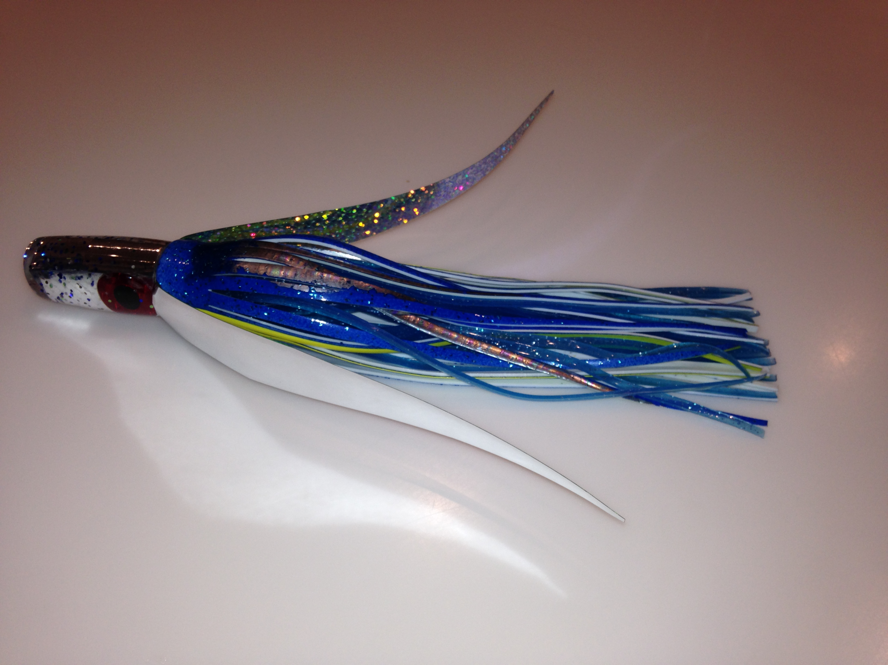

A beautiful flying fish imitation lure used by big game fishermen, and (inset) the real thing airborne over the ocean

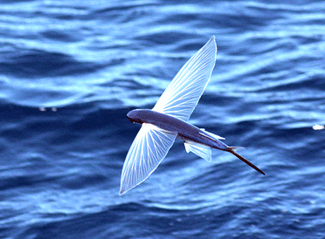
However, when flying fish are around, a skirted lure is dressed up with an extra set of silver wings and rigged so that it skitters around on the surface looking like a frightened flying fish about to get airborne can make all the difference. It’s no guarantee, but explosive strikes from blue marlin crash tackling flying fish lures have to be seen to be believed.

Oh... and where have the marlin been this week? Who knows, but neither they nor flying fish have been anywhere near Coffs Harbour, because it’s been pretty dead out there for days now.

Rick O’Ferrall
www.fromtheflybridge.com

