From the Flybridge 11 February 2017

The weirdness of the summer marlin season continues to keep game fishermen off balance. Nothing is predictable any more. All the inshore reefs and bait grounds are crawling with prime bait in the form of slimy mackerel and bonito, which usually guarantees that the black marlin will be here in big numbers at this time of year. But most of the big pelagics are unaccountably absent.

Local game boat Better than Vegas went for a run out to South Solitary Island for a bit of a look during the week, and despite driving through lots of bait activity, nothing was interested in the lures being trolled behind until the return trip to Coffs Harbour, when out of nowhere, a juvenile black marlin charged a lure and hooked up, waking skipper Pete English out of his slumber. The fish gave him a bit of a workout, mainly because Pete was out there on his own, and running up and down from the flybridge of a 38-foot big game boat keeping it pointed in the right direction while a crazy little marlin is jumping all around the ocean is no mean feat.

Meanwhile the Black N Blue team was out there as well, apparently looking for the one black marlin off the Coffs Coast that Pete English eventually ran over. All they could find were sharks, so they gave up in frustration after numerous encounters with bronze whalers, and headed out wide.

When they arrived at the edge of the shelf, they’d only had the marlin lures in the water for a just a couple of minutes, when a big striped marlin charged in and hooked up.

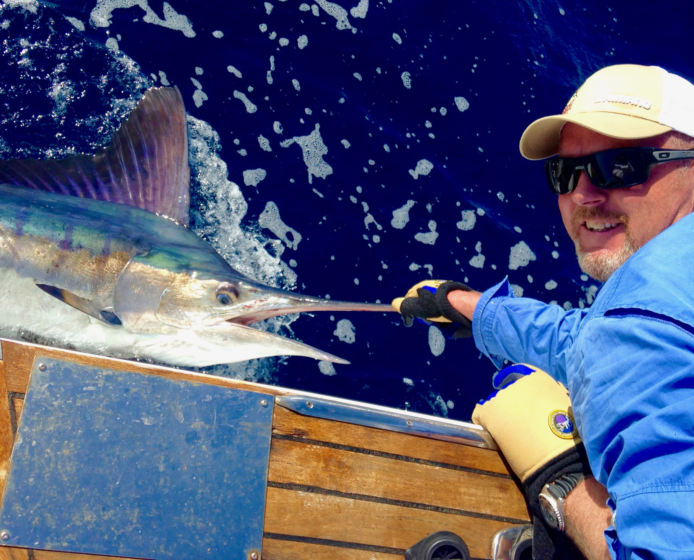

A big striped marlin off Coffs Harbour in February...who’d have thought it.

It’s worth pointing out that while striped marlin are unpredictable at the best of times, the one thing you can usually rely on is that they don’t much care for the late summer 27.5C water that this one was cruising around in. Clearly, all bets are off this year, and skipper Rob Lang and angler Gerrard Billings were happy to see the big 120kg fish prove the usual rules wrong.

Most of the striped marlin on the east coast are generally found in cooler water between Port Stephens and Hobart in late summer. So finding that the stripes are still active off the Coffs Coast in February really deepens the mystery about this crazy summer… but who cares… a marlin is a marlin!

Rick O’Ferrall
www.FromtheFlybridge.com

