From the Flybridge 11 March 2017

Practically every reader on the NSW north coast will understand why there’s no game fishing news this week. It’s plain ugly out where the game fish are.

Another east coast low pressure system spinning away down in the Tasman towards New Zealand has subjected the coast here to days of howling southerlies and wild surf, and the game fishing fleet has been securely tucked up in the harbour. Yet it was only a week ago that occasional marlin were still biting, and you could almost walk across the big mackerel around the inshore reefs.

Despite the disappointment of not being able to get out fishing, the timing of these lousy conditions at least provides game fishermen with a chance to get boats and gear ready for the upcoming Heavy Tackle Challenge tournament. This is the biggest game fishing competition on the coast north of Port Macquarie, and runs for two days every March during the height of the marlin fishing season.

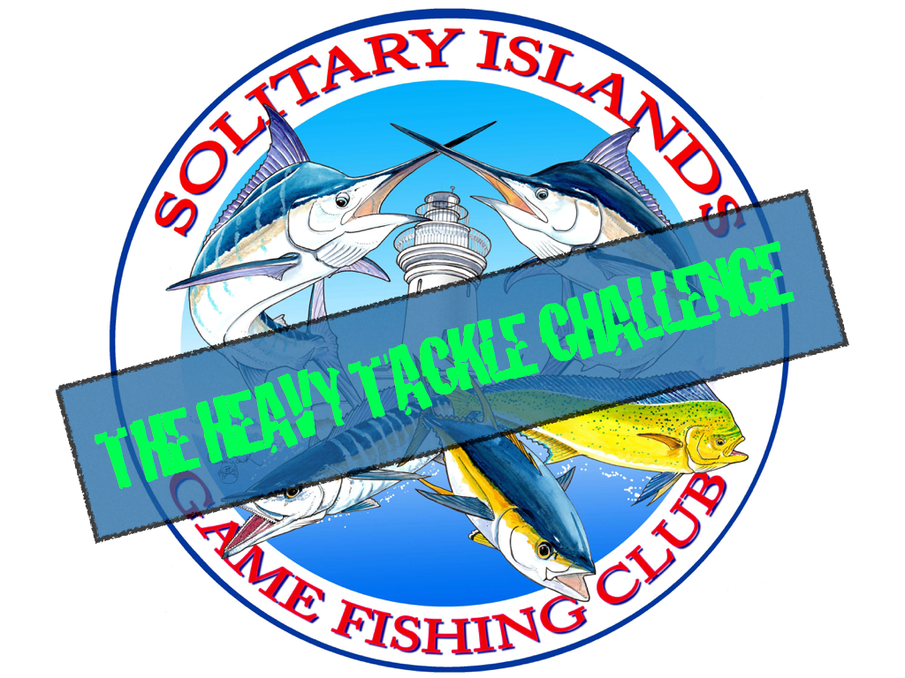

The tournament is hosted by the local Solitary Islands Game Fishing club, and in the past, has attracted big game anglers from as far away as Victoria and Queensland.

This year, the event will run over the weekend of 25/26 March.

The HTC has always attracted a big field of experienced anglers, enthusiastic sponsors, and keen interest from the east coast game fishing community each year since its inception. This year, despite these preceding weeks being marred by weird weather and relatively low marlin numbers, the bigger fish that have been caught out there recently have created plenty of interest, with entries from local and interstate anglers starting to build.

One of the biggest attractions of this tournament in the past has been the regular appearance of large numbers of big blue marlin in March. There are usually plenty of other striped and black marlin to chase in the waters of the Coffs Coast, but with additional tournament points going to crews who tag and release blues specifically, this usually draws competitors to the blue marlin grounds beyond the deep side of the continental shelf where the bonus points that can be earned from tagging one of these peak predators make the distance, difficulty, and extra team skills that come into play worth the effort.

For two years in a row now, teams from the Port Macquarie game fishing club have taken out the champion boat prize, and it goes without saying that local anglers are very keen to ensure that there’s no “threepeat”.

Rick O’Ferrall
www.FromtheFlybridge.com

